Notes App Project Plan Draft
Team Appers
Team Members: Alex Anderson, Jonathan Beck, Donald Greenstein, Justin McCarthy
Date: March 2, 2026

Table of Contents
Introduction ................................................................................3 Scope and purpose of document....................................................3 System Scope...............................................................................3 Problem/Opportunity Description ..................................................3 Anticipated Business/Personal Benefits ...........................................3 System Capabilities ....................................................................3 System Context.........................................................................3 Schedule....................................................................................3 Staff Organization .........................................................................4 Team Structure..........................................................................4 Tracking and control mechanisms .....................................................4

Introduction: Alex
System Scope Part One/Tracking: Donald
System Scope Part Two: Jonathan
Organization: Justin
Schedule: Shared (Alex, Donald, Jonathan, Justin)

Introduction
Scope and purpose of document AA

This project plan document outlines the structure, scope, and organization of the Notes App project. It details the project schedule, staff organization, and tracking and control mechanisms to ensure successful completion. Responsibilities are clearly assigned among team members, and tools such as GitHub, Trello, Google Drive, and Slack are used for collaboration and project management. Overall, the purpose of this project plan is to serve as a structured roadmap that defines the goals, responsibilities, and coordination methods for the development of our app.

The Notes App is a mobile-PC hybrid text editing application designed to provide a streamlined and efficient note-taking experience without requiring a computer. Unlike many traditional text editors that are poorly optimized for mobile devices, this app prioritizes usability and accessibility. It allows users to view and edit multiple file types such as PDF, TXT, and Markdown, includes built-in real time language translation with automatic language detection, and features keyword mapping for quick referencing and custom redirects. The app also offers multiple sorting options for organizing notes and comprehensive customization capabilities, including themes, layouts, tab sizing, and folder positioning, giving users full control over their workspace.
System Scope
Problem/Opportunity Description DG

Our goal with this project is to create a mobile-focused text editor that can be used seamlessly with numerous file types and on the go. The problem with many mobile ports of desktop-laptop focused text editors is that they often contain inadequate proportions in their interfaces due to the fact that they were not made with mobile usage in mind. We realize that at this point in time, most if not all people have some sort of mobile device, and are often on the go and don’t necessarily have an excess amount of time to sit down and use a computer.
Anticipated Business/Personal Benefits DG

With this project, we’re hoping to create a mobile alternative to solve this problem that implements countless features that other competing applications do not currently have.

We’re hoping that users will be able to access, read, and edit documents more easily throughout any point of the day. We are planning on implementing local and cloud storage, so Wi–Fi connection will not be a large problem for those who are often in places without a secure and stable Wi-Fi connection.
System Capabilities JB

Keywords with their own pages - This function will allow the user to type in a certain word/phrase that will link to a note page that they assign it to. Along with this, the user will be able to link words to outside sources like Wikipedia, YouTube, etc.

UI c ustomization - This function will allow the user some customization to make the pages have their own style, and to take notes in their own way.

Formatting file types - This function will allow the user to paste in a file (like .docx, .txt, .pdf, etc.) that will be automatically made into edit-able text.

Translation - This function will translate the desired text into the language the user chooses.

Sorting - This function will allow the user to sort their notes as they please. They will be able to sort as usual by date, or name, but will also add new sorting features, like being able to drag/drop/pin whatever files wherever they want.
System Context JB
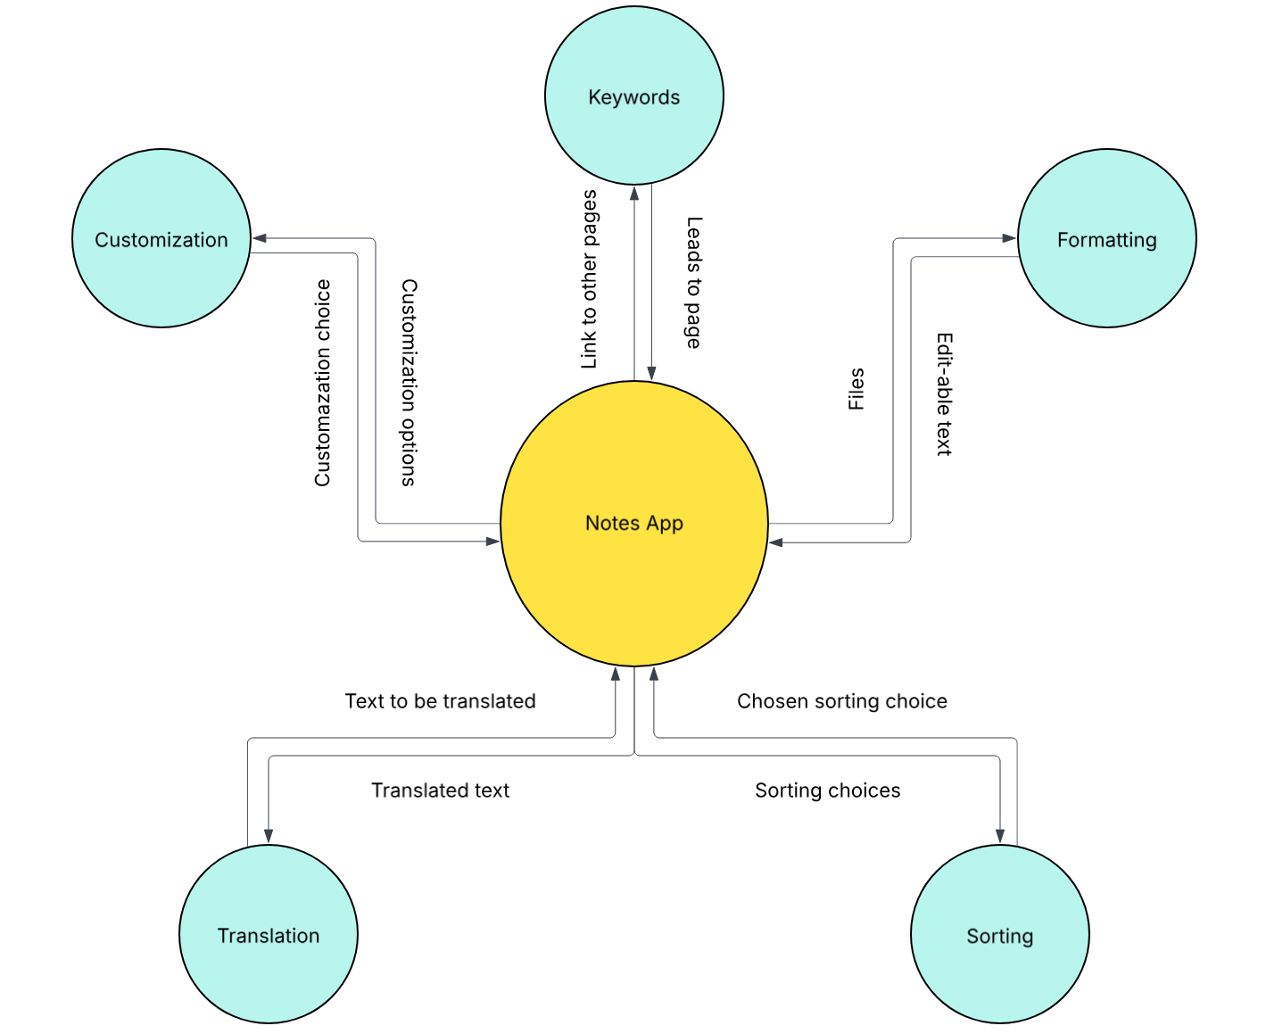
Schedule
Using MS Project/Project Libre, create a Work Breakdown Structure Chart, identifying all tasks required to complete this team project, dependencies and staff resources for each of the tasks. Include phases to group and organize your tasks and include milestones.
Submit the schedule file as a separate file from your plan document.
Staff Organization JM

Our team leader is Donald, and we’re organized by having our own GitHub repository, Trello workspace, Google Drive folder that this outline is in, Slack channel, and canvas on Slack with links to GitHub and Trello. Donald has shown the most team leadership traits so far by creating what’s on GitHub, Trello, and Google Drive, and sharing them with the rest of us soon afterwards.
Tracking and control mechanisms DG
Trello - Keeping track of all tasks and who is assigned to do what tasks

Slack - Communication tool to keep in contact with one another and ensure that everyone is on track and completing whatever it may be that they are supposed to do

Google Workspace - Free and easy to use cloud-based workspace that allows all group members to work on and access any document simultaneously

Microsoft Project/Visio - Most up-to-date and efficient planning and system diagram creation tools at our disposal to plan ahead and stay focused on the task at hand

